**WEEK 7 HANDSON -REACT**

**HandsOn 12 :**

**TASK :**

**In this hands-on lab, you will learn how to:**

* **Implement conditional rendering in React applications**

**CODES AND OUTPUTS :**

Create a React Application named “ticketbookingapp” where the guest user can browse the page where the flight details are displayed whereas the logged in user only can book tickets.

The Login and Logout buttons should accordingly display different pages. Once the user is logged in the User page should be displayed. When the user clicks on Logout, the Guest page should be displayed.

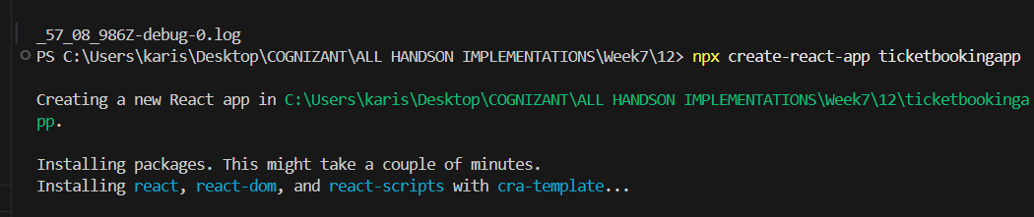

npx create-react-app ticketbookingapp

cd ticketbookingapp

cd desktop

Project folder :

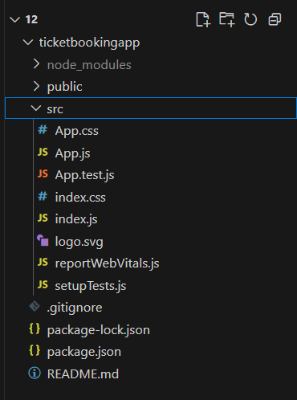

Creating login and logout buttons on different pages :

**GuestPage.js :**

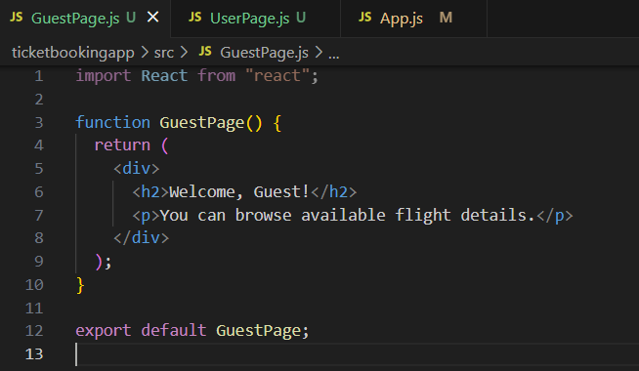

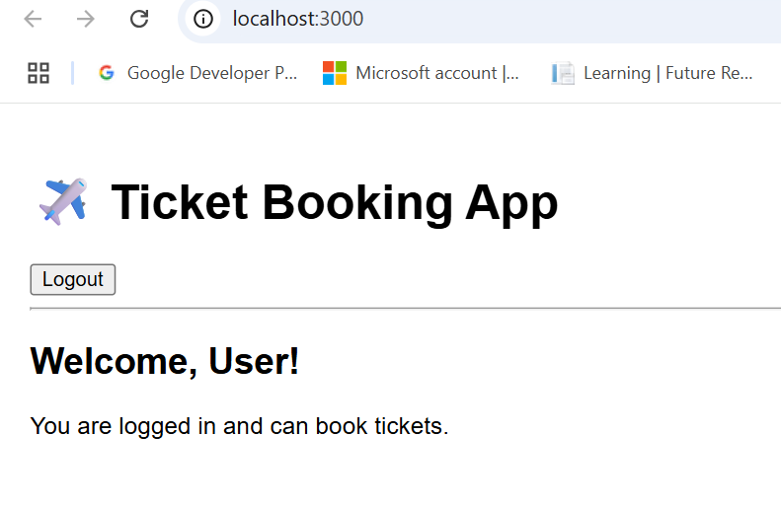

**When user is not logged in:**

* **Shows GuestPage**
* **Displays Login button**

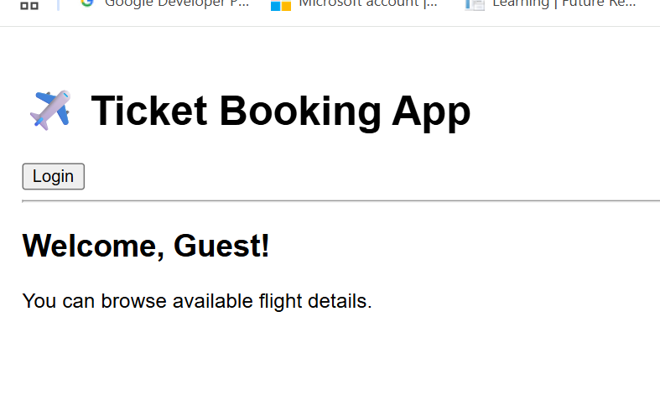

**Userpage.js :**

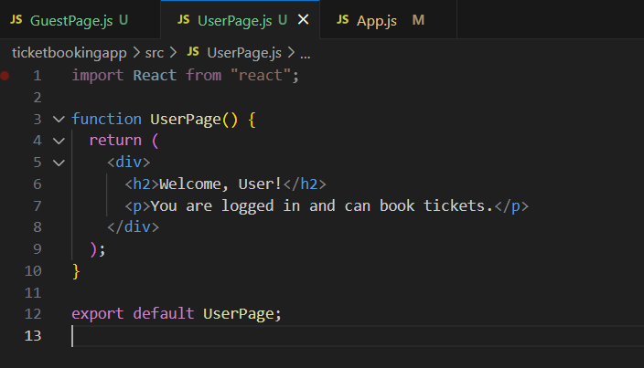

.Once the user is logged in the User page should be displayed. When the user clicks on Logout, the Guest page should be displayed.



App.js :

import React, { useState } from "react";

import GuestPage from "./GuestPage";

import UserPage from "./UserPage";

function App() {

  const [isLoggedIn, setIsLoggedIn] = useState(false);

  // Toggle login status

  const handleLogin = () => {

    setIsLoggedIn(true);

  };

  const handleLogout = () => {

    setIsLoggedIn(false);

  };

  // Element variable for conditional rendering

  let page;

  if (isLoggedIn) {

    page = <UserPage />;

  } else {

    page = <GuestPage />;

  }

  return (

    <div style={{ padding: "20px", fontFamily: "Arial" }}>

      <h1>✈️ Ticket Booking App</h1>

      {/* Conditional Buttons */}

      {isLoggedIn ? (

        <button onClick={handleLogout}>Logout</button>

      ) : (

        <button onClick={handleLogin}>Login</button>

      )}

      {/* Conditional Page Display */}

      <hr />

      {page}

    </div>

  );

}

export default App;

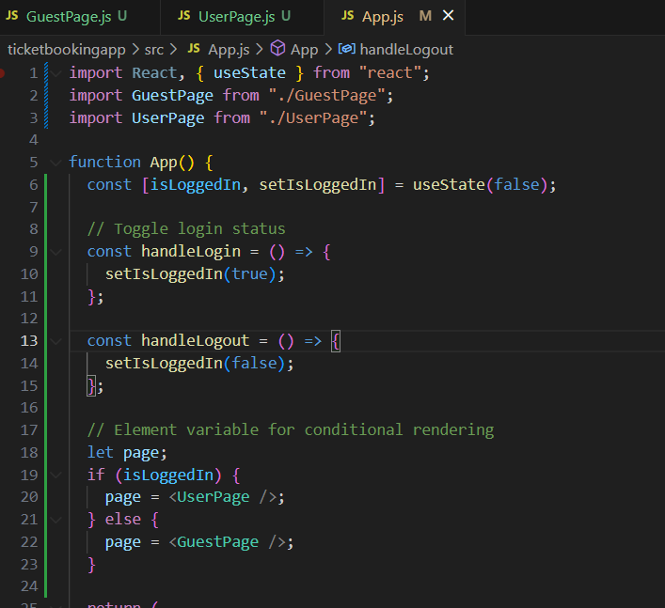

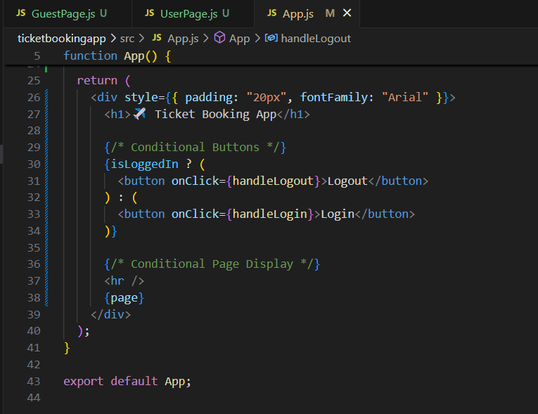

**Finaly full output :**

**Before login :**

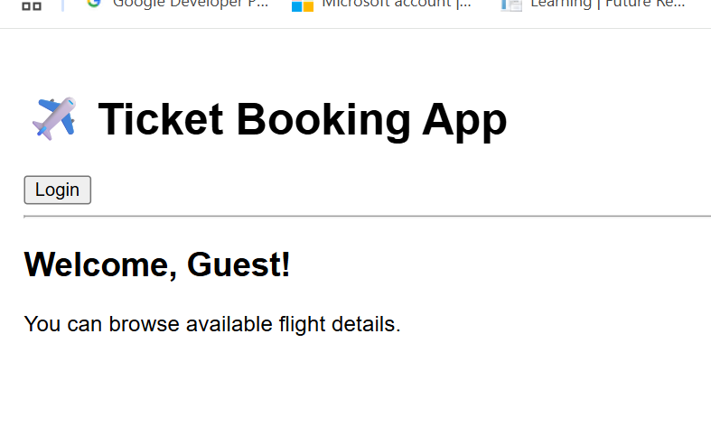

**After login :**

